

**A.V Bhargava(191911110)**

**AIM :**

To execute Automation testing using Selenium tool for online food application

**PROGRAM**

package sse;

import org.openqa.selenium.By;

import org.openqa.selenium.WebDriver;

import org.openqa.selenium.WebElement;

import org.openqa.selenium.chrome.ChromeDriver;

//import org.testng.Assert;

//import org.testng.annotations.Test;

public class food {

public static void main(String[] args) {

System.out.println("hai");

System.setProperty("webdriver.chrome.driver","C:\\CSA37 Lab details\\Sellinium and junit\\selenium jar\\chromedriver_win32\\chromedriver.exe");

WebDriver driver = new ChromeDriver();

//driver.get("https://www.google.com/");

driver.manage().window().maximize();

driver.get("https://life.saveetha.com/");

WebElement username=driver.findElement(By.id("txtusername"));

System.out.println(username);

WebElement password=driver.findElement(By.id("txtpassword"));

System.out.println(password);

WebElement login=driver.findElement(By.name("btnlogin"));

System.out.println(login);

username.sendKeys("192011013");

password.sendKeys("#baba1610");

login.click();

}

}

**OUTPUT**

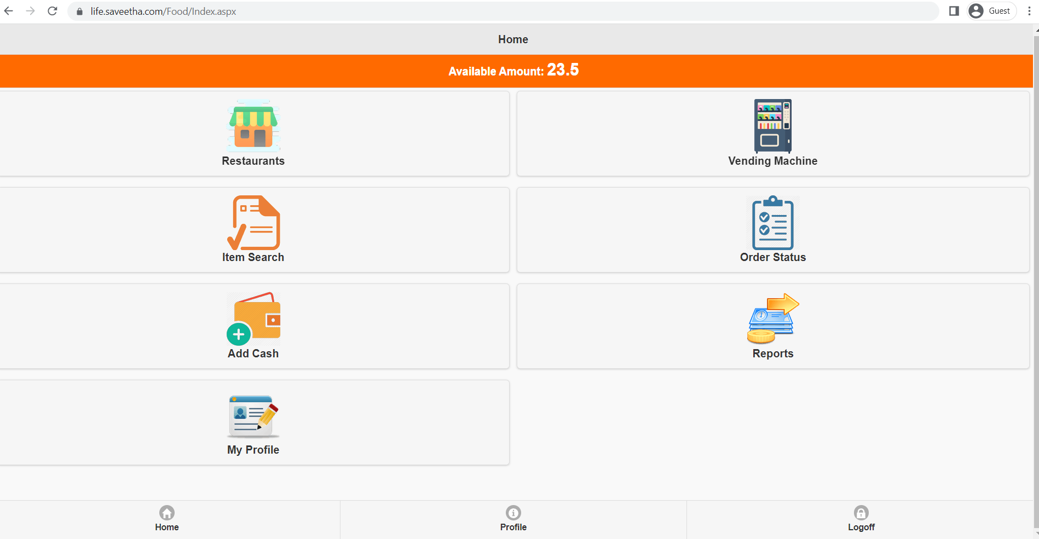

**RESULT**

Hence Automation testing for online food application is Executed successfully.